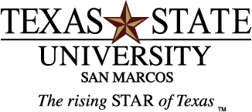

Volunteer Families Needed
Families with at least one child above the age of 6 are needed to participate in an educational intervention, using curriculum for the National Institutes of Health WeCan! Program, to improve physical activity levels in family members.
Over the course of 11 weeks, families will be asked to attend 7 meetings (4 educational, 3 for testing and follow-up). The meetings will be held at the Dunbar Community Center in San Marcos. The majority of the meetings will last approximately 60 minutes and will focus on how to improve physical activity levels and decrease sedentary time in all family members.

For additional information contact
Stacia Miller, MEd. at 512-245-2246 or sm66@txstate.edu.

Volunteers who participate in the Intervention will be eligible for prize drawings during each session.
